Communications Resources (updated 09.28.25)

HOW THE BOARD COMMUNICATES WITH MEMBERS

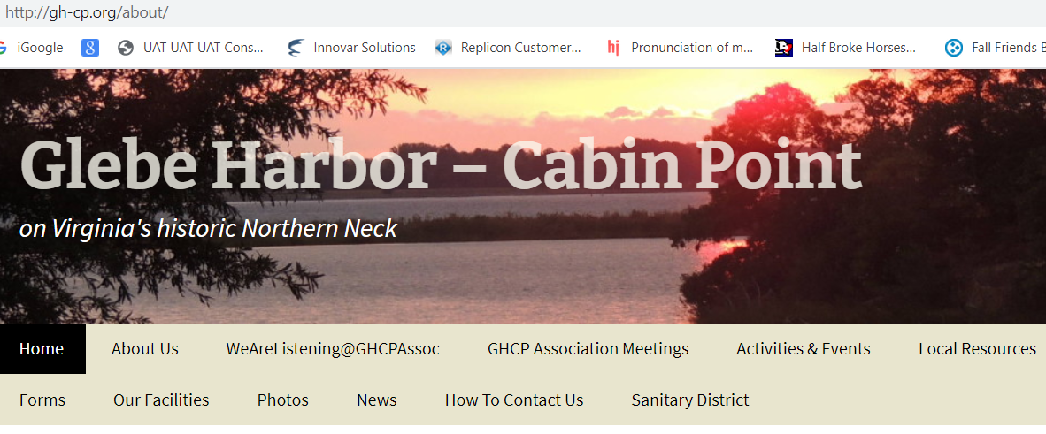
GLEBE HARBOR – CABIN POINT Website: http://gh-cp.org
http://gh-cp.org/
Your best source of valid information about the Association, the Sanitary District, and our resources:
- Latest NEWS
- Glebe Harbor & Cabin Point Maps and Covenants
- Contacts: County, Emergency, Local Service Providers...
- Forms: Property Owner Info, Boat Trailer Decal, Rental Agreements, Leased Property Form…
- Meeting & Activity Notices
- Official documents and rules governing the GHCP Association and the GH-CP Sanitary District, Membership Directory, minutes of Board Meetings, and some other documents are password protected; member login required.
MONTHLY NEWS Emails
Sent to emails provided on your Property Owner Information Form, which can be found under Forms on website:http.//gh-cp.org.
- Monthly notices giving the headlines of recent NEWS items posted on Glebe Harbor-Cabin Point website
- Official notifications of general membership meetings
- Emergency notifications with potential impact on GHCP property owners/residents

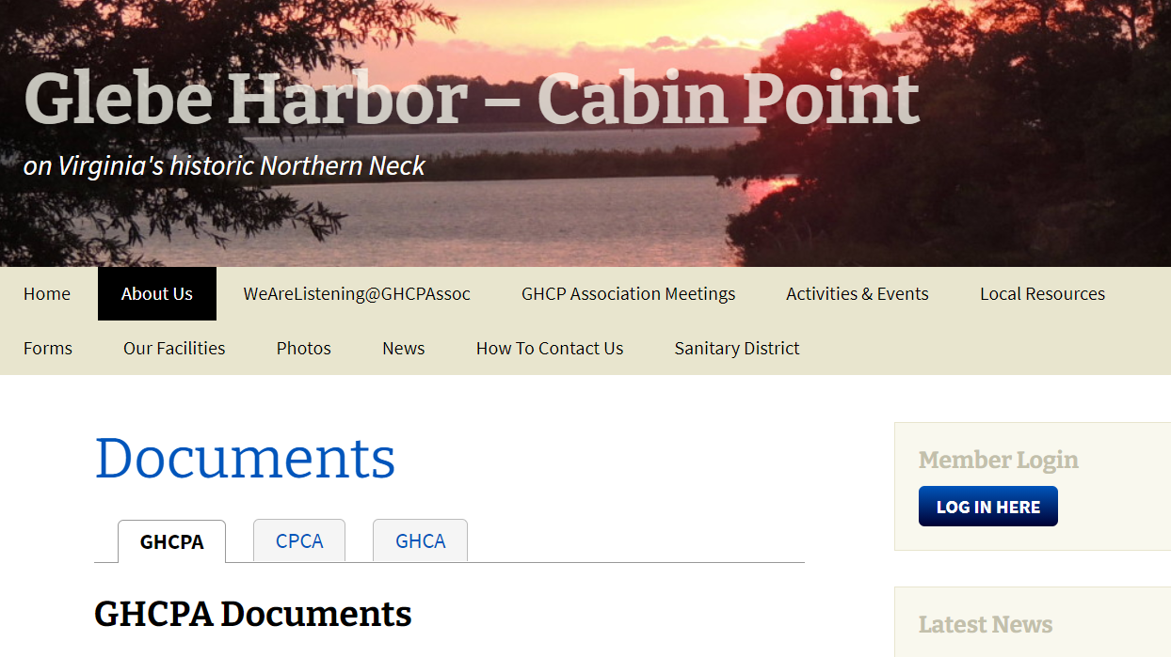
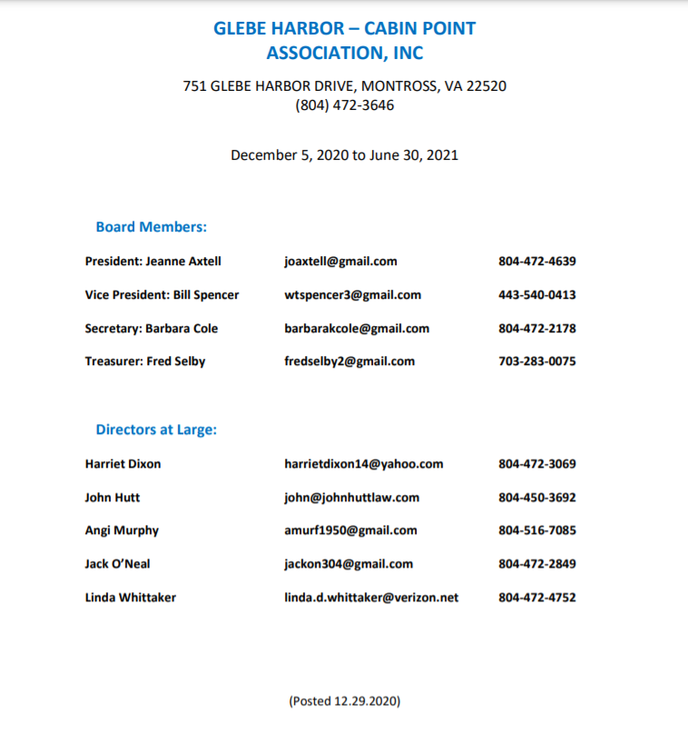
- Sent out alerts needing immediate notification
HAPPENINGS Emails
Sent to emails found on Property Owners Information Form
- GHCP activities and events
- Weekly notices (or as needed)
- Not currently receiving “Happenings” and want to be included? Call the clubhouse (804-472-3646)
VOLUNTEER Interest Group Emails
Sent to emails that have expressed an interest in volunteering with the Association
- Volunteer opportunities include lending a hand in organizing activities, general work sessions (e.g. getting pool ready), leading projects, offering website/IT support, maintain trailer parking, serve on the GHCP Board, etc.
- Not currently receiving the “Volunteer” emails and want to be included? Call the clubhouse (804-472-3646)

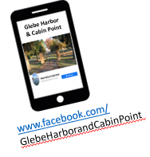
GHCP Facebook Page
- https://www.facebook.com/GlebeHarborandCabinPoint
Membership SURVEYS
- Member Surveys carried out yearly

CLUB HOUSE Bulletin Boards
GHCP Office Mgr. – Teresa
804-472-3646

HOW MEMBERS COMMUNICATE WITH THE BOARD
EMAIL your comments, questions, and suggestions to GHCPAssoc@gmail.com
CALL the GHCP Office: 804-472-3646, Office Mgr. – Teresa
CONTACT Any Board Member *
RESPOND to our annual Membership surveys
*Board Members and their contact information listed on gh-cp.org website under The Association tab.

INDEPENDENT COMMUNITY COMMUNICATIONS SERVICES
Westmoreland County VA Website go to westmoreland-county.org
Westmoreland County VA Emergency Management facebook page
GHCP Yard Sale facebook page
Nextdoor is a social app for neighborhoods to exchange information, goods, and services. You may receive an invitation to join, or you can go to www.nextdoor.com to create an account and sign up.
Glebe Harbor & Cabin Point Owners/Residents Group is an independently run Facebook page. You must be approved as a legitimate owner or resident to join.
