GHCPA Cabin Point Beach Project
Chronology of Construction from October 25 to December 7, 2023.
(Editor’s Notes: Credit to Debbie Dever, Chair, Waterway Committee for the text and daily photos posted on Glebe Harbor – Cabin Point Community News. This is an abridged version excerpted from Debbie’s postings and photo album.)
October 25 -- Day one of construction laying the filter paper and smaller rock foundation before placing the large armor stone for breakwater #2 at Cabin Point Beach.
October 26 -- Day 2 of Cabin Point Beach. Lots of filter paper is being put down today and small rock foundation.
October 27 -- Day 3 is windy, and the river is rough, but the work continued with larger rock. The barges are all tethered offshore after finishing for the day, so they do not damage the breakwaters or groins.
October 28 -- Day 4- no work today but some low tide shots of the work in progress. Have a safe Halloween and great weekend.
Day 5/6- missed yesterday. There was a lot of progress over the two days. Two barges are working now AND another sand barge arrived.

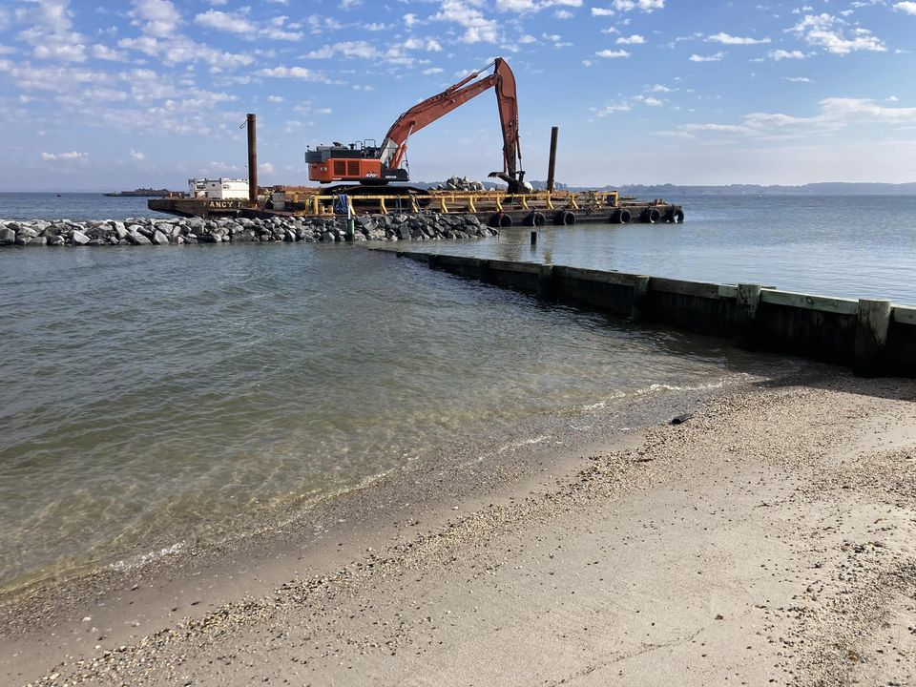

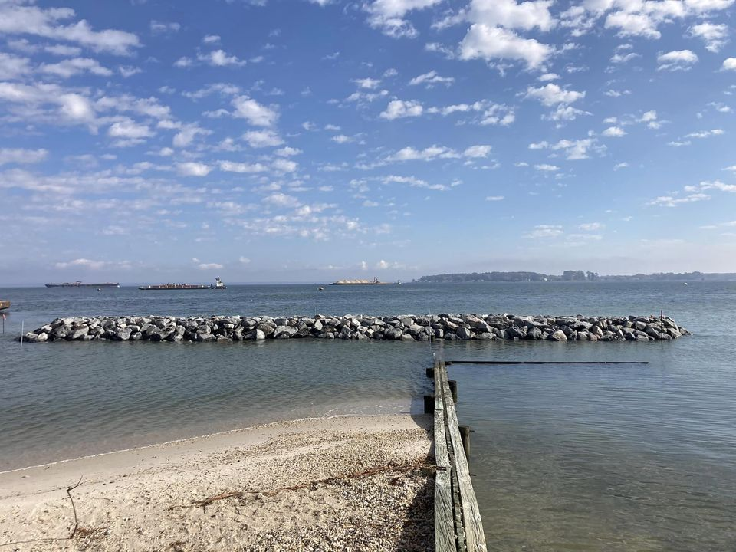

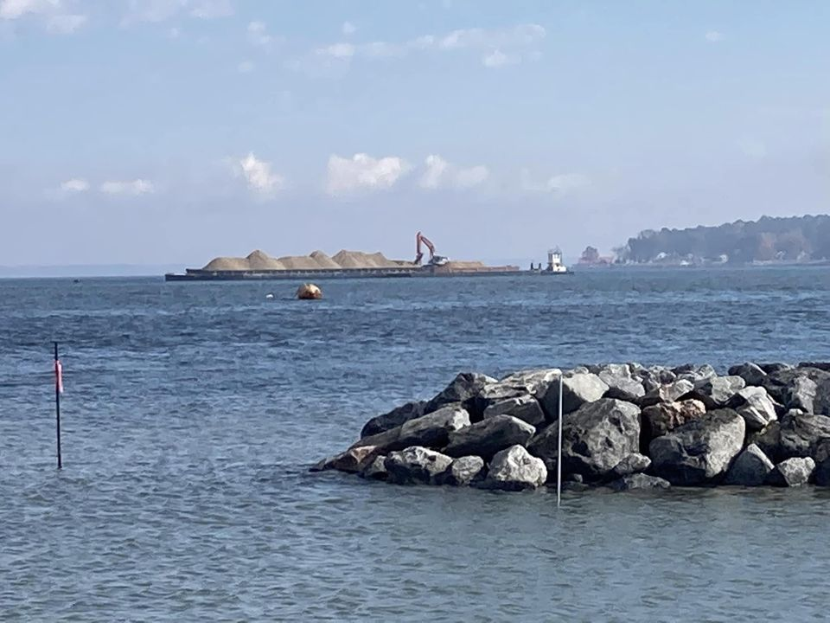

November 2 -- Day 7 and so much amazing progress. The first rock barge is empty, and they have begun backfilling the groins with sand. Fascinating to watch them use machines like hand extensions.

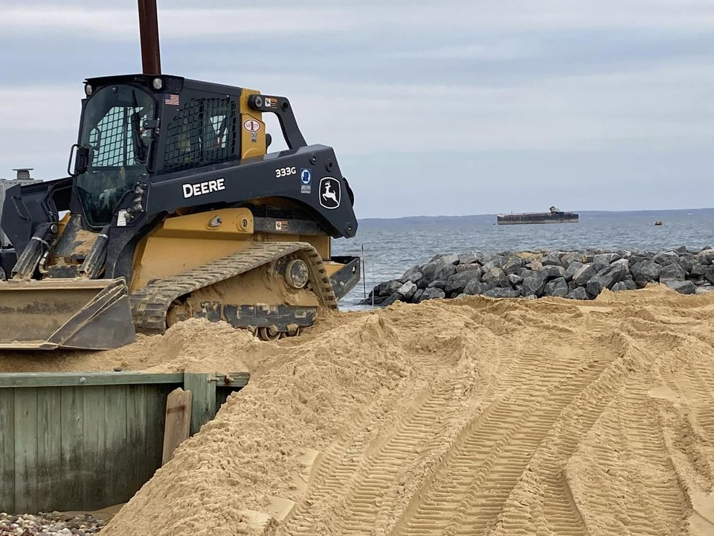

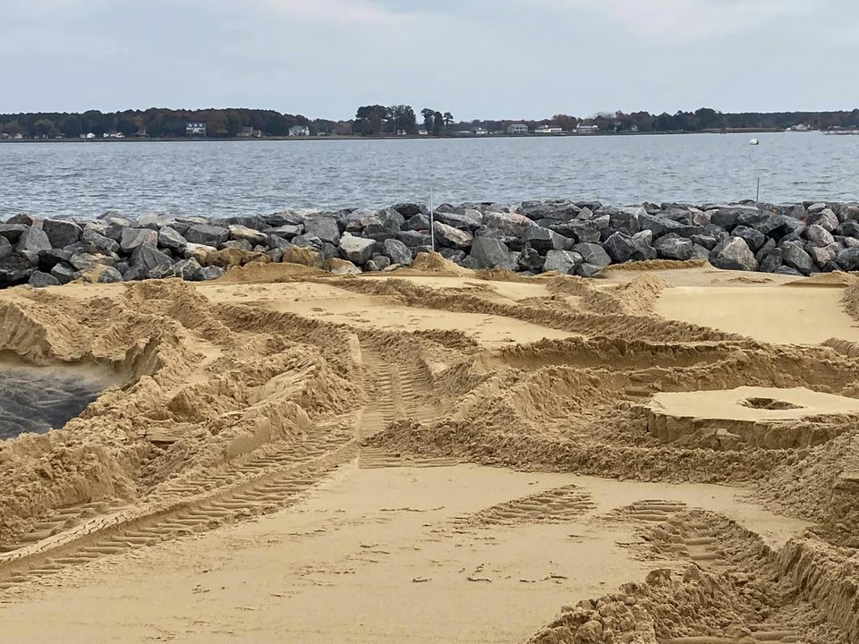

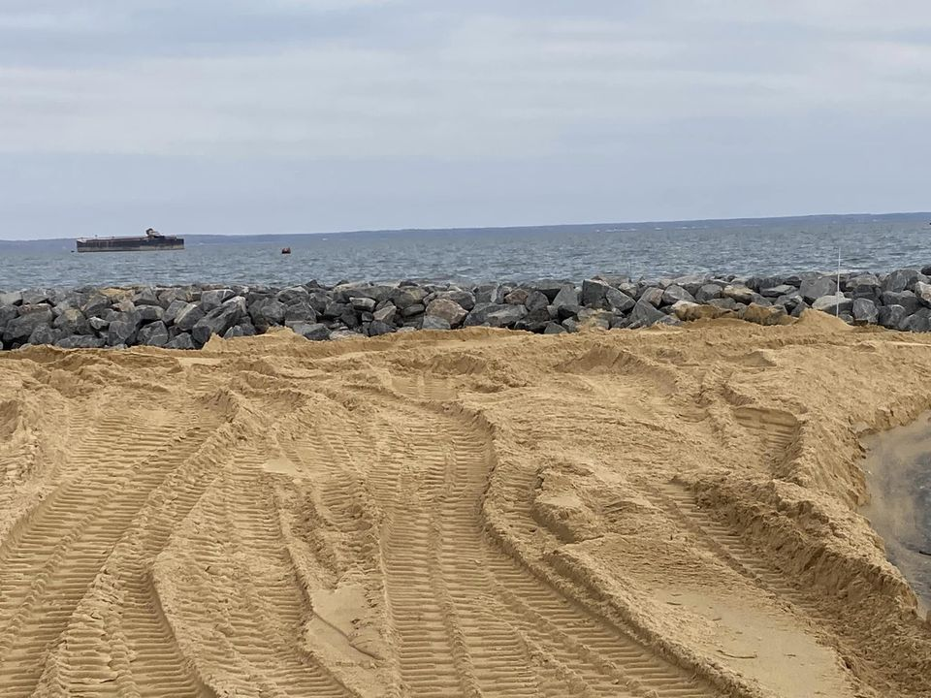

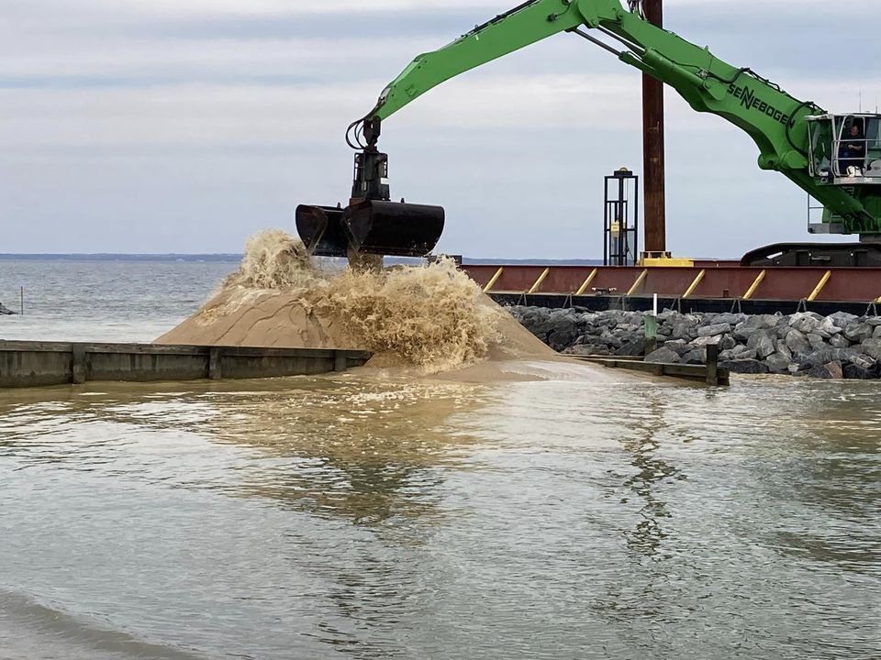

November 3 -- Day 8- slow day. A little sand was moved around while they waited for the next rock barge.
November 7 -- Day 9 -There is a lot going on today. A new rock barge arrived last night. Breakwater construction starts again. The first sand barge is almost empty and will return to Delaware for a new load of sand. There will be another rock barge arriving when this one is empty.
Just a little background on the workers. Where do they go each day after work?
The man with the twin engine boat lives just across the river is St. Mary’s. The men stay there during the week and head home on Fridays. Some live in Williamsburg, some in VA Beach. The large tug is docked at the house where the men are staying. They cross 9 miles by boat every morning to get to the job site.
November 8 -- Day 10- Bit of a Rough commute this morning as the river is angry today. Even with the wave action, the work continues. More rocks are being placed today. The sand is already starting to bleach out and turn white.
November 9 -- Day 11 - Lots of rock work being completed today. The barges were busy building up the breakwaters.
What is a breakwater? A breakwater is an offshore shore-parallel structure that “breaks” waves, reducing the wave energy reaching the beach and fostering sediment accretion between the beach and the breakwater. (Editor’s note: credit Janet Zwirner for today’s photos.)
November 14 -- Day 15 - A lot is going on today. Two excavators working at each end. Almost 6 breakwaters finished. Watch how they use the machine like an extension of their hand to place 1 rock. They use the water to wash the small rocks into the crevasses.
November 15 -- Day 16 - Cloudy and cold but still working. Breakwaters 1-6 are done. Putting down filter paper for #7. Watch how the excavator maneuvers the paper and then anchors it with armor stone. Next step is laying the smaller base of rocks to support the large stones.

November 16 – Day 17 - What is under that pile of rocks they are building? See the diagram. Two empty barges left today. They finished #7 and half of #8 breakwaters. Next up, extending the channel rock and building up the height of the current rock.

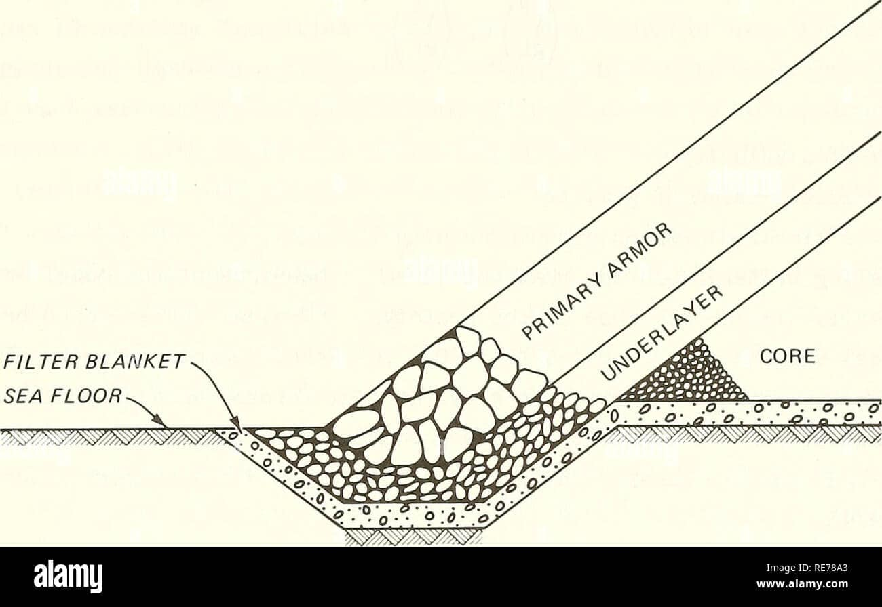
November 18-- Day 17 and 18 - Friday is an off day for the crew. They worked yesterday to finish breakwater #8. All the barges are empty. One more rock barge on the way to complete #9. Then on to the extension of the channel rock and raising the height of the rock. The working barge is parked at the last breakwater before the channel. The beach looks amazing.
November 21 -- Day 19 - The rock barge arrived, and work has begun on the channel extension. The length and height of the inlet channel will be increased.
FUN FACT - what are those jelly blobs on the beach? If you have had a chance to walk the beach lately, you may have seen a lot of what looks like jellyfish on the shoreline. These are not jellyfish; they are tunicates otherwise known as “salps”. They are 97% water and feed on phytoplankton which is plentiful when the water is warm. When their food source is gone, they die off and wash up on the shore. By the time they reach the shore, they are dead. They come in many shapes and sizes. At Cabin Point, they look like jello blobs.
November 22 -- Day 20 - VERY busy today. Two excavators “Rock” in and rolling. One excavator working on breakwater #9, laying back filter paper. The second excavator built up the height of the channel rock. We also received another load of sand at breakwater #1. This sand is black but should wash out clean.
November 23 -- Happy Thanksgiving Eve. The crew stopped around 1:30 today for the holiday. Another load of sand was placed on #7. The “rivah” was beautiful today. Channel rock is finished and #9 is half done.
November 24 -- Happy Thanksgiving from our welcome beach visitors. They seem to be enjoying the remodeling project.

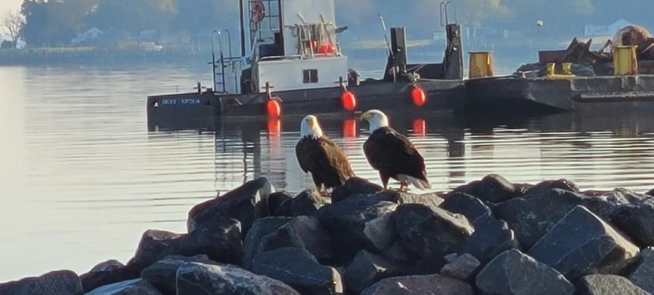

November 28 -- Day 22 - Breakwater #8 is complete and #9 is about 50% completed. White caps in the water this morning so a bit rough out there.
Fun fact- How much rock has been barged from Delaware for this project? Well, the contract called for 542 CY. What the heck is a CY? A CY is a cubic yard. So, what does that mean in terms of tons. Here is a test of your math skills for those who want to have fun…
A cubic yard of rock equals 3000 pounds, A short ton weighs around 2000 lbs., so number of tons, 3000/ 2000 = 1.5 short tons, in this regard, “how many tons in a cubic yard of rock”, so, generally there are 1.5 short tons of rocks in a cubic yard. This is the standard weight of rock in tons per cubic yard used for billing purposes. (Editor’s note: we later learned this contractor uses 1.6 short tons of rock in a cubic yard for this project.)
November 29 -- DAY 23 - THE SANDMAN ARRIVED TODAY. Sand is being removed from the channel and placed at breakwater 7 and 8. All the breakwater structures are completed. More sand will be removed from the channel tomorrow. This crew works long hours but when quitting time comes, the tug captain gathers the crew and full steam ahead back to the Maryland shores.
November 30 -- DAY 24 - A rainy day but that does not stop the work or the daily report. Sand, sand, sand and more sand is being placed on the shoreline behind the breakwaters. The sand being placed is coming from the Cabin Point channel inlet.
Fun Fact #1 - Who are these guys doing the work? The company is Coastal Design and Construction owned by Jim Gunn. Since March 1978, James Gunn has served as Principal Owner and President of Coastal Design & Construction, Inc. He has more than 45 years of experience in all aspects of marine construction. His expertise includes living shorelines, dredging, rock structures (revetments, jetties, groins, breakwaters), stream restoration, tidal marsh creation, and wetlands mitigation.
Fun Fact #2 - What’s with the names on these barges? Well, the main barge CD&C stands for the company name and was built in Norfolk about 5 years ago. The RICHARD E. And RICHARD C. are named for the owner’s father and son. The LUCY is named after his wife. The EMILY is named after his daughter.
December 1 -- Day 25 - Cold day but the work continued. The jetty is finished, and the sand has been spread. Inspection tomorrow morning to review what is left to be completed. Oyster shells will be arriving to complete the living shoreline project.
December 2 -- Day 26 - The rock and beach work are complete. Oyster shell seeding hopefully starts Monday. The barges are leaving and heading to their next job. Jeanne Axtell (GHCPA President) and Debbie Dever (Chair, Waterway Committee) met with the owner and project managers today to inspect the work. Two of the barges will be going in for repair. The rest will be headed to a two-year project.
Fun Fact - The sand which was purchased for the project came from the Nanticoke River in Seaford, Delaware and was brought here on barges. The remainder of the sand replenishment came from the man-made portion of the CP Creek inlet channel.
December 3 -- Thanks to everyone who attended the GHCPA community meeting today. Stay tuned for the wrap up of the Cabin Point Beach project next week. Oysters are on the way. NEXT UP: Community beach clean-up day for our beaches coming in the spring.
December 7 -- FINAL DAY - well this project is complete for now. Today was the final day of work and the oyster shells were spread to complete this living shoreline project. We will be doing inspections throughout the year to evaluate the project. The oyster shells are shot through a machine on the vessel.
FINAL FUN FACT - How many oyster shells were spread on the front/river side toe of the breakwaters… 12.7 tons or 450 Bushels of Virginia Oysters.

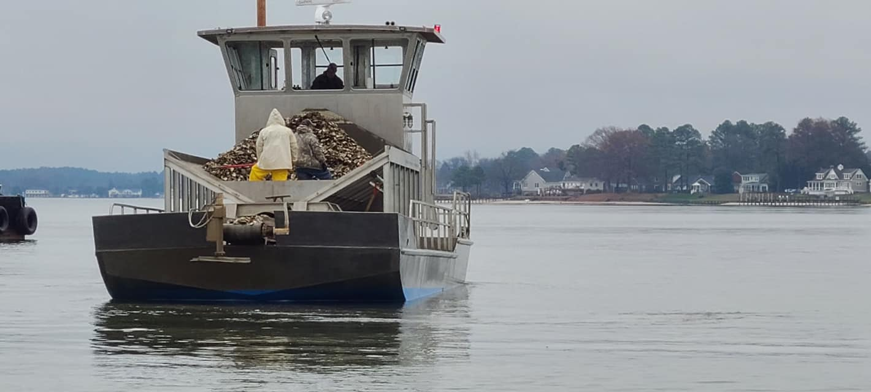

(Editor’s final note: The post-construction inspection was completed on December 14.)

