Westmoreland High School Grand Opening

The new Westmoreland County High School is nearly complete. The convocation for the opening is scheduled for Saturday, July 30th at 10 am. The public is invited to attend. Tours of the new school facility will be available to students, parents, and County residents.
This provides an opportunity to view the facility prior to school opening for classes the following week. Save the date and plan to attend this special opening of the County's new High School!

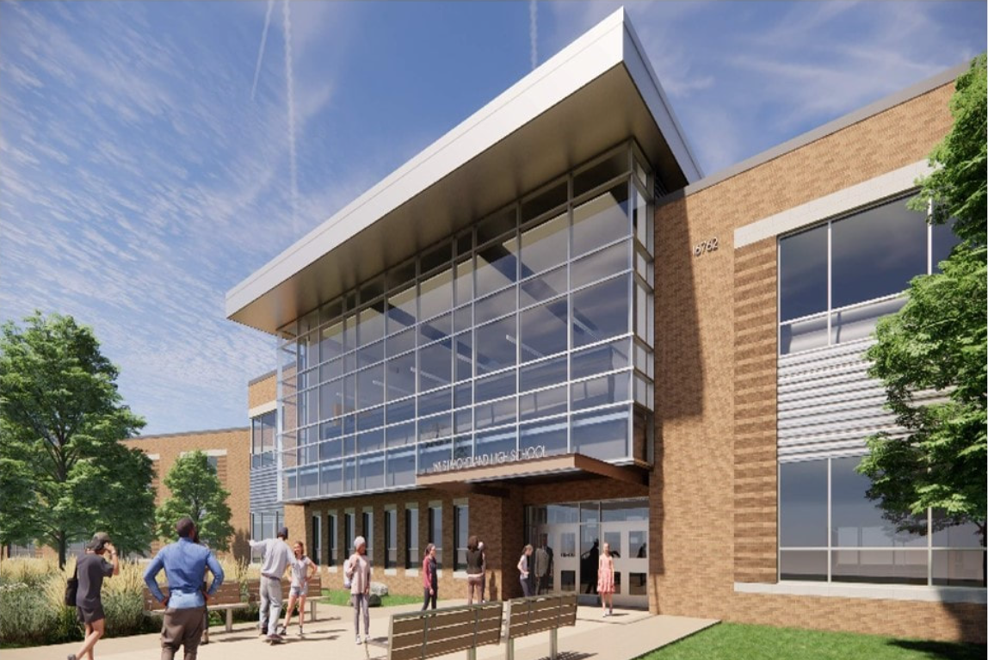 | 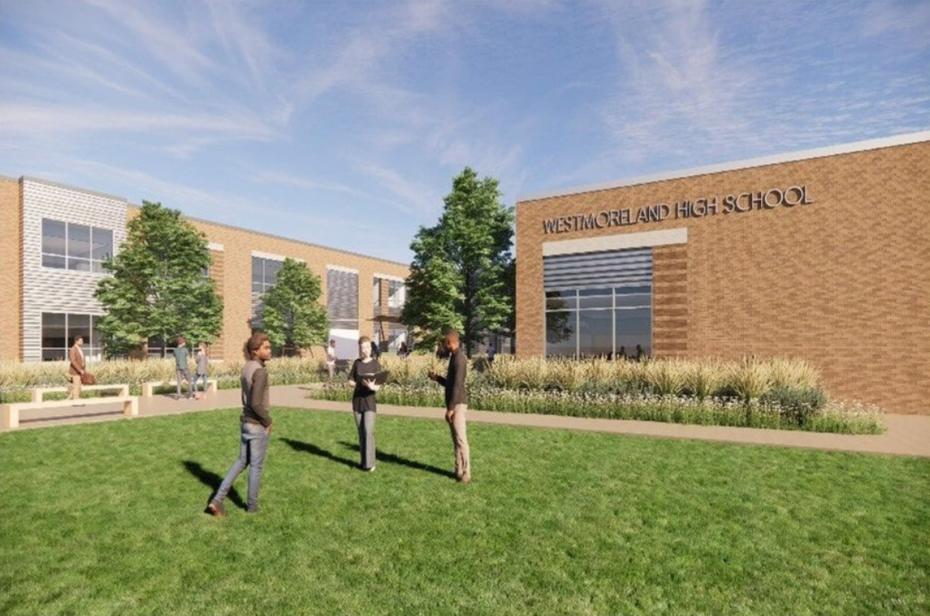
(06.30.2022)

