GHCP 2022 New Member Orientation Event
On Saturday, May 21, the GHCP New Member Orientation event was held at the Clubhouse. This was the second year for this event.

It was organized to share the history of the community with new members, explain how the community is organized and managed, and to provide an opportunity for new members to learn more about various activities available to them in Glebe Harbor and Cabin Point.

Nine stations were set up around the Rotunda in the Clubhouse, giving new members the opportunity to meet and greet other presenters who could share one-on-one and answer questions about the community.

This was an informal and fun event. Two gift baskets, filled with donated items from local merchants, were given away. An informative and fun time was had by all.

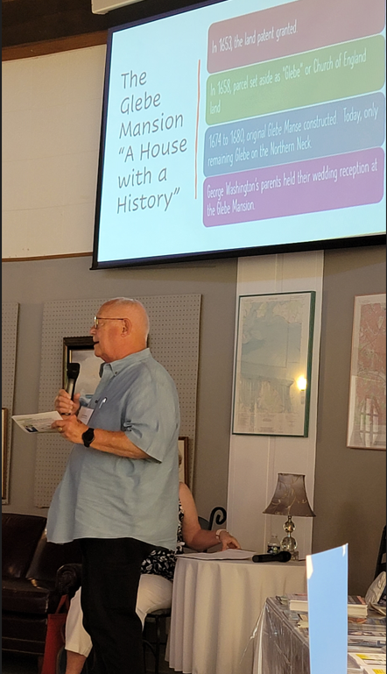
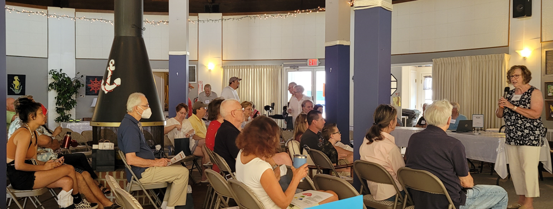
(06.30.2022)

