A Memorable Memorial Day Weekend Was Had By All !
Great things happen when nice people converge at a great venue in perfect weather! That’s how our community made the Memorial Day Weekend a truly great way to kick off the summer season! Over the three-day weekend, 538 members and guests signed into the pool. Given the surge in home building, it’s not a big surprise that a quarter of the access cards presented over the weekend were issued since January 2021. Welcome again to our old friends, and to our new members and their families!
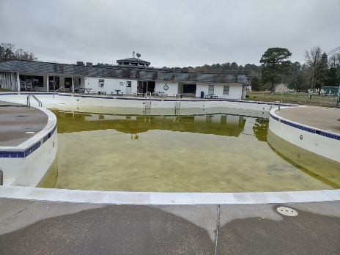 | 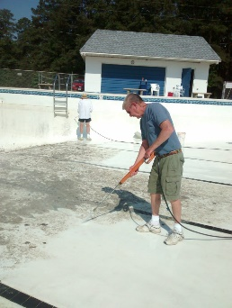
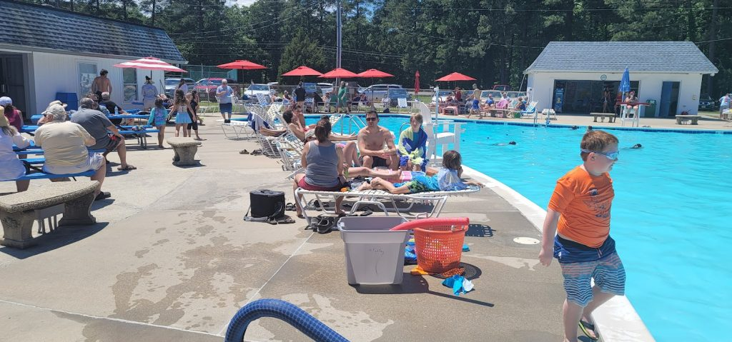

Special thanks are due, as they always are, to the volunteers, who in its 54th year transformed our “recreational facility” from a frog swamp, to the pool you can enjoy today. Also, to everyone who cleaned, prepped, painted and repainted everything we see and touch at the pool and our other facilities. My estimate is the 32 individuals put in over 400 hours to achieve the transformation. And another tip of the hat goes to the "Friends of the Pool" and other volunteers who organized the cookout and served 120 burgers and dogs on Memorial Day Weekend.
If you are curious about what it takes to keep our facilities up and running, you can sign up for our interest group – Volunteer Opportunities – that will send you more detailed emails about facilities concerns and activities in GHCP. You can subscribe by scrolling down to the bottom of this email, click on Update My Preferences, and follow the directions. If you later change your mind, you can unsubscribe the same way.
And thanks again for all you do to keep GHCP - a Great Place to Live!
(06.30.2022)

