Our Community is Powered by Volunteers –
Here’s How YOU can help!
Lend a Hand

Occasionally we will schedule a general work session, and put out a call for volunteers to pitch in on a specific project. Getting the pool ready for the season is our biggest annual challenge.
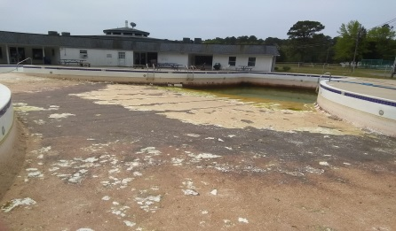
While it’s a bit early to nail down specific dates and times, here’s a rough schedule of what needs to be done this year:

Week of April 18 - Restart the well pump, check for leaks. Determine other needs for painting at the pool, begin surface preparation. Diagnose the condition of the hot water heaters, begin to move furniture out of the pool garage, inventory, and identify repair and replacement needs. Begin pressure washing the pool decks. Begin to review and update pool rules & procedures.

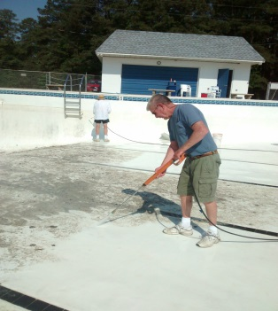
Week of April 25 - Shock the well, chlorinate water system. Test for bacteria. Inventory pool chemicals and supplies, evaluate well water chemistry, and order chemicals. Complete pressure washing of decks. Replace one of the two 5hp main pool circulation pumps. Begin pump out.
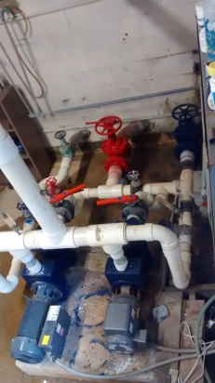
Week of May 2 -Paint bathrooms as needed. Clean out office and garage area. Post new signage. Begin to pressure wash interior of the pool. Repair/replace lap lane ropes. Repair/replace the vent fan in pump room. Dig out a shallow trench under the chain link fences around the pool. Fill the trench with gravel to inhibit weed growth and improve drainage off the deck into the grass.
Week of May 9 - Replace burned out light in diving well. Paint/repair/replace blue tables as needed. Begin to refill the pool by May 15.
Week of May 16 - Pressure wash remaining furniture, set up the decks.
Week of May 23 - Balance chemicals, install lane ropes, complete setup for the season.
Pool Opens Saturday, May 28
Dates & times of work sessions will be posted in NEWS and sent directly to folks who are subscribed to the email Volunteer Opportunities group. Please consider helping when you can.

Lead a Need
Every project in our community needs some planning, preparation, and organizing before the actual “work” can get started. Please take a look at these examples. If something else is of interest to you please let us know, at ghcpassoc@gmail.com.
Pool furniture
We have some money this year to buy new furniture for the pool this year. In particular, we are going to replace at least two of our six round blue picnic tables. All are still sturdy, and all need paint, but eight of the 24 fiberglass seats (4 per table) are cracked and should be replaced. New parts don’t seem to be an option, but it looks like salvaging enough good seats to repair 4 tables is an option. We also need to replace at least 6 table umbrellas, and more broadly assess our overall needs for furniture and decoration at the pool. So the job is part design, part shopping, and part recruiting help for repairs.

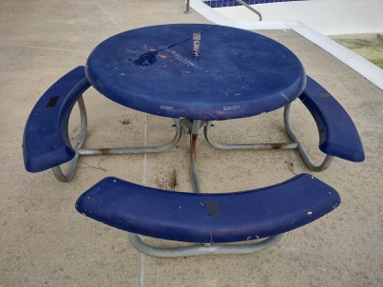

Mardie Amery has done quite a bit of shopping on line and found suitable replacements for two of the round tables. But we are also looking for a volunteer to evaluate our other needs, shop around for affordable options, and recruit some help to take a serious look at table repair and painting. Please email or call Dot Spencer if you can help. (dorothy.r.spencer@gmail.com, or 410 491 7400)

Help Maintain Trailer Parking
Our trailer parking facilities at the Clubhouse, the Cabin Point boat ramp, and the Glebe Harbor Beach require periodic attention. Spaces are marked by numbers painted on concrete blocks on the ground. They get run over and broken up, and those that don’t need to be replaced need to be repainted every year. The lines themselves need to be repainted every 4 to 6 weeks during the year, and we have budgeted funds for gravel or millings to resurface some of the areas that are frequently wet and soft.

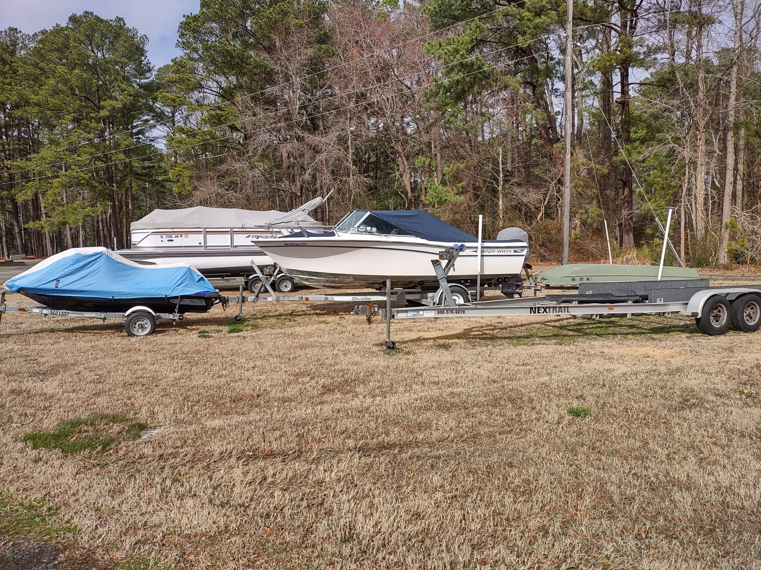

Looking for a volunteer to help maintain these areas, paint the lines as needed, and work with Mount Holly Lawn Service (they mow the grass) to ensure weed control around the parking space markers, and take the lead on getting gravel installed where needed. Please email Bill Spencer at wtspencer3@gmail.com if you can help.

Cabin Point Boat Ramp Restroom Renovation
This is a significant project, and will probably be a combination of professional and volunteer effort. We want to restore the bathrooms to working condition. The scope of work needs to be defined in greater detail to repair known problems (rot in wood trim, probable roof replacement, plumbing leaks) and result in two refreshed bathrooms connected to the County sewer. Our budget includes some funding, but we need a lead who could take on the project as if it were being done at your house. Likely to be a blend of hired professional and recruited volunteer help.

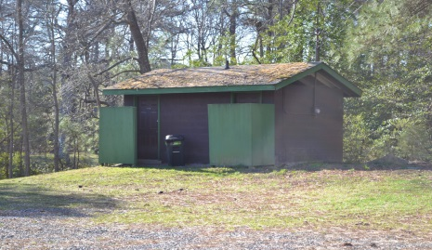

Looking for a volunteer to take the lead, acting in whatever role works for you, from general contractor to concerned homeowner hiring out some of the work, and soliciting volunteers for the rest please email Bill Spencer at wtspencer3@gmail.com if you can help.

Repair of the “Snow Fence” at Cabin Point beach
Actually, it’s more of a “Sand Fence”, installed after the channel was dredged last year to keep sand from blowing back into the channel. The fence has fallen over, but 3 or 4 people could set it back up in an hour or two. It may also need a few more stakes, but it looks pretty straight forward.

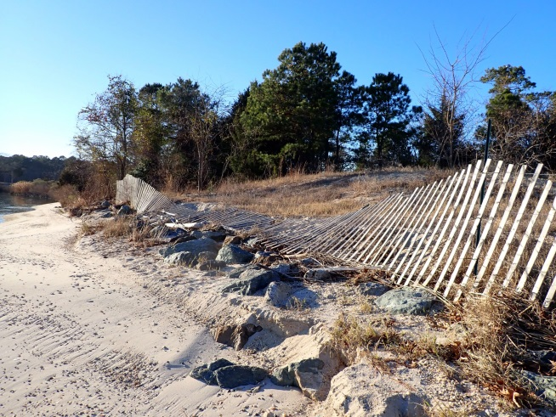

Looking for a volunteer to round up a couple of folks to check it out and get it done. Please email Bill Spencer at wtspencer3@gmail.com if you can help.

The Association Facebook Pages
We would like to make our Association Facebook page a more useful way for people to hear about current events in the community. One step we would like to take is to move the postings that have been on the Pool FB page over to the Association page to reduce put more information on one site, and to reduce the admin effort required.

So, we are looking for a Facebook volunteer to help make that happen. If you can help, please email or call Dot Spencer. (dorothy.r.spencer@gmail.com, or 410 491 7400)

Get Involved with One of These Groups

The Facilities Committee

The Facilities Committee is a group of volunteers, invited by the Director of Facilities to provide the representation and expertise needed for projects under consideration. It’s a forum for members who would like to be more involved in identifying facilities needs and proposing solutions to the Board for approval and resources.

You can read the formal charter of the committee HERE, but in a nutshell, members will:
- periodically survey Association facilities
- develop and recommend plans, cost estimates, and priorities for needed work
- recommend to the Board what projects are appropriate for volunteers from the community, and those for which bids for vendors should be solicited
- organize volunteers and/or assist in procuring vendors in accordance with County procurement requirements to carry out approved projects
When projects are approved and funded, the committee will be authorized to execute those approved plans.

Contact Bill Spencer wtspencer3@gmail.com to learn more.

Friends of the Pool

This is an informal group of folks who like being involved with pool planning, entertainment events, and operations throughout the season. Generally, they assist with planning events at the pool, solicit volunteers, assist with pool concessions, lifeguard orientation and support, and are willing to help out as needed.

Contact our Pool Coordinator Dot Spencer at Dorothy.r.spencer@gmail.com, or call 410 491 7400 for more information.

Serve on one of the GHCP Boards
We have 3 Associations in GHCP, each with its own elected Board of Directors
- The GHCP Association manages, operates, and maintains all GHCP recreational facilities on a day-to-day basis for the benefit and use of all property owners. Every property owner is a member of the Association.
- The Glebe Harbor Civic Association and the Cabin Point Civic Association are voluntary membership organizations whose primary functions include covenant enforcement, maintenance of non-state roads, and representation of their communities’ particular interests to outside parties.
All depend on volunteers to serve as officers, and on volunteers to support their efforts directly.
As a property owner, you have the opportunity to have a voice in how GHCP is managed; to contribute time as a volunteer; to vote on matters brought before the Associations; to stand for election to the Board of Directors; and to serve on Committees. Please call the office or any of our Association or Civic Association board members for more information.

3.6.2022

