Member Services – Events
I hope everyone had a nice Thanksgiving!

The summer and fall activities in and around the community have kept us all pretty busy and it doesn't seem to be slowing down.

Come by to see how festive the Clubhouse looks. Decorating trees and hanging wreaths was a fun time had by all with lots of chatter and later, a brunch to say "thank you" to the volunteers. If able, please drop off an unwrapped toy to go under the Christmas tree. The toys will be collected by the Westmoreland County Department of Social Services and distributed to children in our county during the holidays.

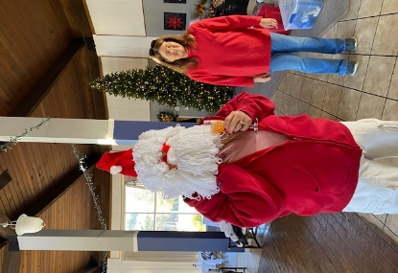 | 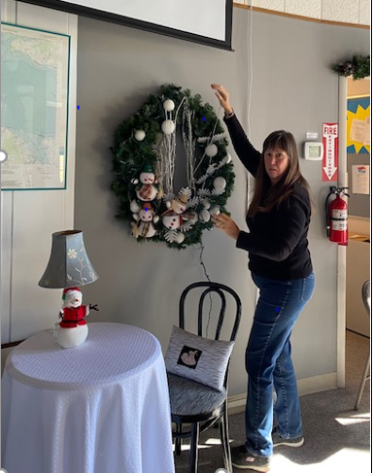
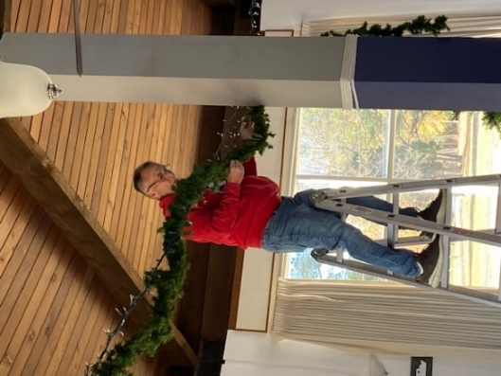 | 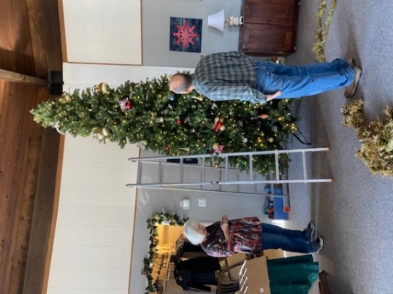
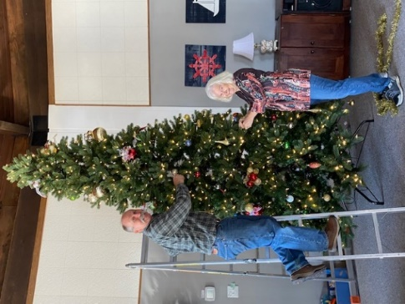 | 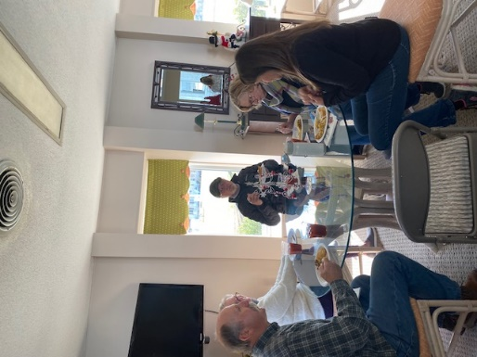
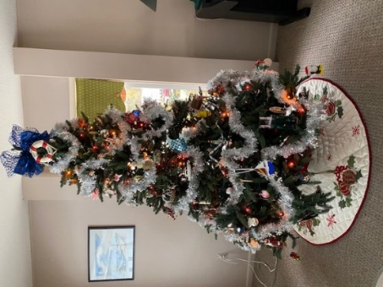

The upcoming events in December, January, and February:

December 11 -- The Adult Holiday Celebration, 6-8:00 p.m. – This event will be hosted by Jane Heron, Janice Fletcher and Angi Murphy (Cost is $45 per person and tickets are limited and the deadline to purchase is December 4). Party will be catered by Brian, owner of Angelo's. Click Link for Flyer.

December 18 -- Children's Holiday Open House, 10-12 noon. –This event is hosted by Angela Bensen & Jason Sherm. RSVP by December 13. Click Link for Flyer.

December 31--- New Year's Eve Party, 8-12:30 a.m. This event will be hosted by Barbie White, Deanna Rudnick, and others. Live Band and appetizers and a champagne toast at midnight.
(Cost is $25 per person and the deadline to purchase a ticket is December 17). Click Link for Flyer.

January 13 -- "Paint and Sip Class."
In addition to our regularly scheduled activities, we have added another. Beginning January 13 and monthly thereafter on the 2nd Thursday from 2-5:00 p.m. Teresa Edwards will be teaching a painting class using oil paints. These classes are limited, and an RSVP is required. Cost is $35 per person, all supplies furnished. Click Link for Flyer.

February 13 -- Super Bowl Party
Mark your calendar!
This event is hosted by Barbie White, Deanna Rudnick, and others. More details to follow.

Tuesday Happy Hours from 5:00-7:00 p.m. have been well attended and the food just keeps getting better. Come join us, bring a dessert or an appetizer to share and your beverage of choice. Thanks to all who participate in this event and especially to those who have hosted.

Angi Murphy, Director
Member Services – Social Events

