Save the Date!!

For the July
“Howl at the Moon Outdoor Game Night”

Everyone had so much fun last time, we are doing it again!!
TO: Glebe Harbor-Cabin Point Residents

WHEN: Saturday, July 24th

TIME: 6:30 p.m. – 10:00 p.m.

WHERE: Clubhouse Pool Deck

WHAT TO BRING: -- your competitive, fun self
-- your beverage of choice
-- water bottles and snacks will be provided

After dinner, turn off your TV, put down the iPad, computer, and books and head up to the Clubhouse pool deck for an outdoor family fun game night – ALL while checking out the full moon!

Games include Ring Toss; Giant: Checkers, Tic Tac Toe, 4-in-a-Row, and Jenga; Corn Hole; Ping Pong; Ultimate Twister; Karaoke; Left Center Right; & Simon Says; and, of course, the pool will be open until 10:00 p.m., as well!! Any questions, call the office at 804-472-3646.

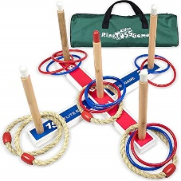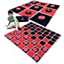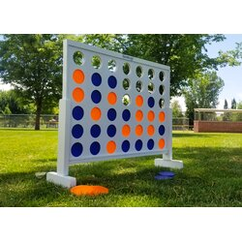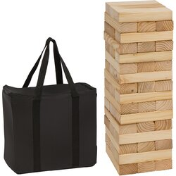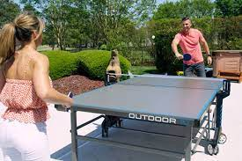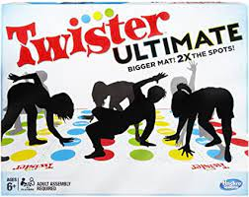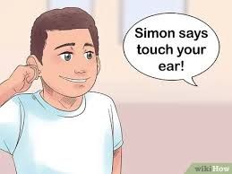

(07.04.2021)

