July 4th Celebration at the Pool

On behalf of the GH-CP Association, thanks to everyone who came out to enjoy the pool and the cookout this Independence Day!

It was nice to see such a good turnout and fortunately we had plenty of burgers and dogs. The ice cream cones at the end were a nice treat on a beautiful day.

Thank you for your participation and continued support of our community, making it a great place to live.

Also, a big thank you to our pool staff and our volunteers!

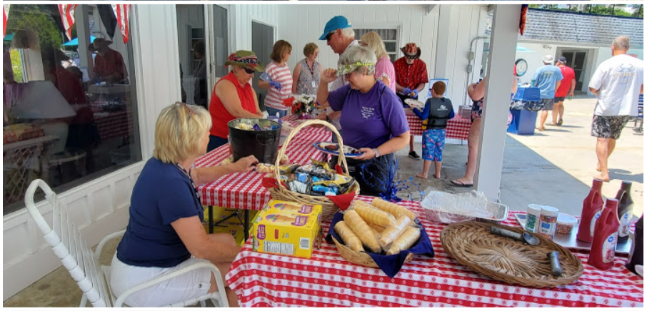

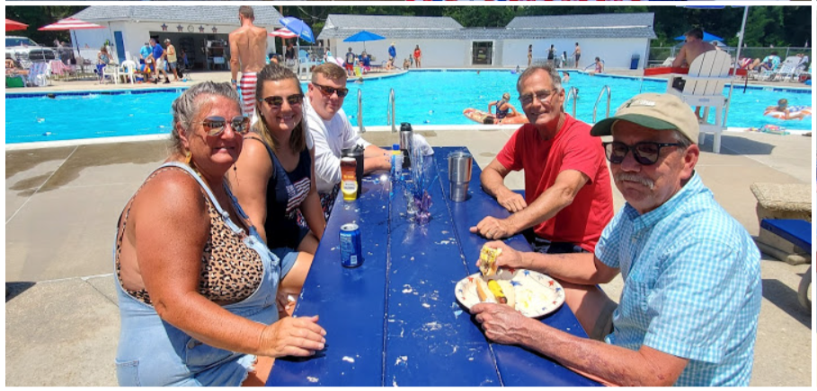
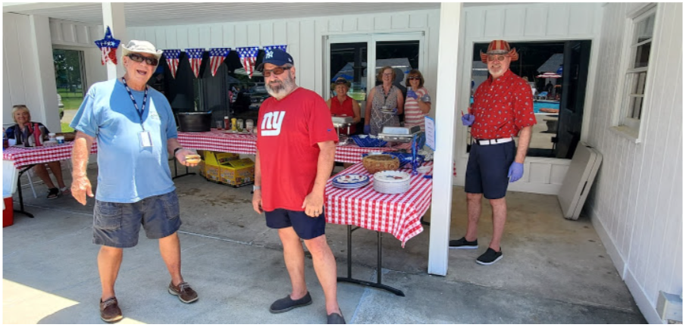
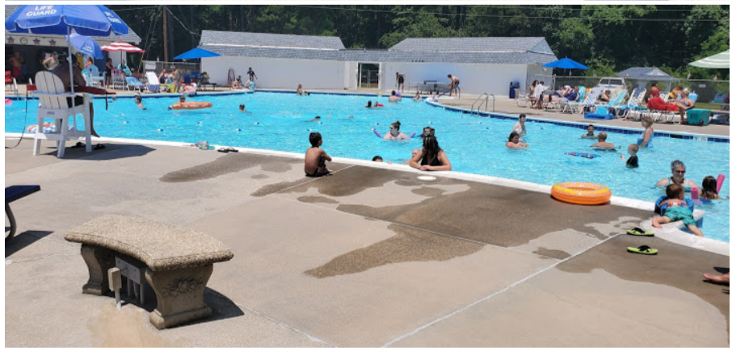
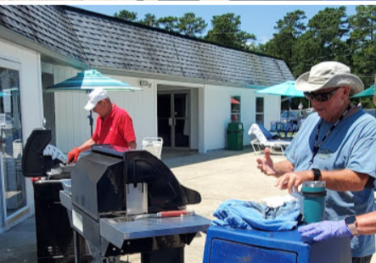 | 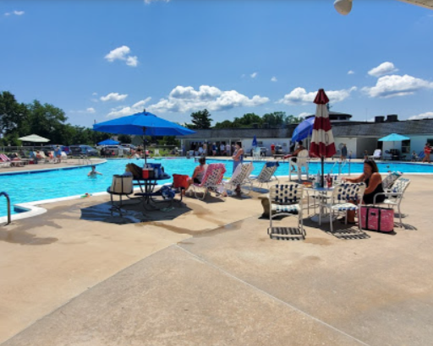

Angi Murphy

(07.05.2021)

