YOU’RE INVITED

Live Music by Jamie & Tyler
during our final summer
Howl at the Moon Outdoor Game Night

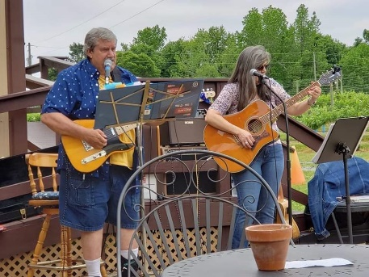
TO: Glebe Harbor-Cabin Point Residents

WHEN: Saturday, August 21, 2021

TIME: 6:30 p.m. – 10:00 p.m.

WHERE: Clubhouse Pool Deck

WHAT TO BRING: -- your competitive, fun self
-- your beverage of choice
-- your dancing shoes

-- water bottles and snacks will be provided

After dinner, head up to the Clubhouse pool deck to hear Jaime & Tyler’s acoustic blend of rock, blues, country and folk music -- ALL while playing games and checking out the full moon!

Games include Ring Toss; Giant: Checkers, Tic Tac Toe, 4-in-a-Row, and Jenga; Corn Hole; Ping Pong; Ultimate Twister; Karaoke; Left Center Right; and, the pool will be open until 10:00 p.m., as well!! Any questions, call Dawn Wharton at 240-753-2920 or Teresa Edwards at the office at 804-472-3646.

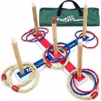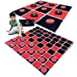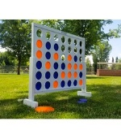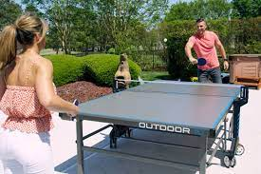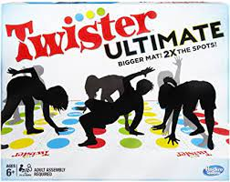

(07.28.2021)

