GHCP Pool Reservations
Members may make one pool reservation per day up to 7 days in advance by calling 804-472-3646 during office and pool hours, or by visiting the pool. (We will not be able to accept new reservation requests left in our voice mail.)
We will ask for your name, the Lot Number on your access card, and the exercise area or lap lane you want to reserve. The map of lanes and exercise is on the back of this page. Your Lot Number is the 6 digit number (or letter/number combination just below the word “Recreational” on the front of your card.
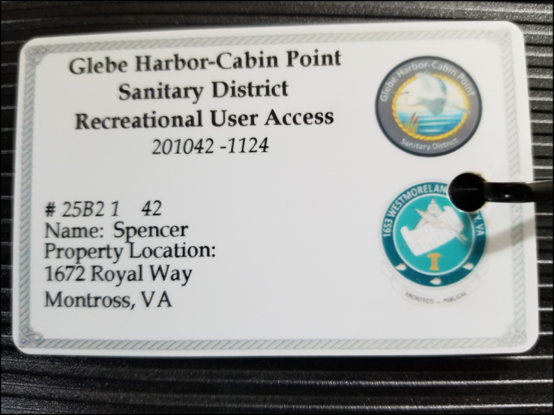
When you check in to the pool to use that reservation, the lot number of the card presented must match the reservation.
All reservation times begin on the hour – 45 minutes for swimming, 15 minutes for cleaning and transition to the next reservation. If you do not check in by 10 minutes past the hour, the reservation will be cancelled and the remaining time given to another group.

