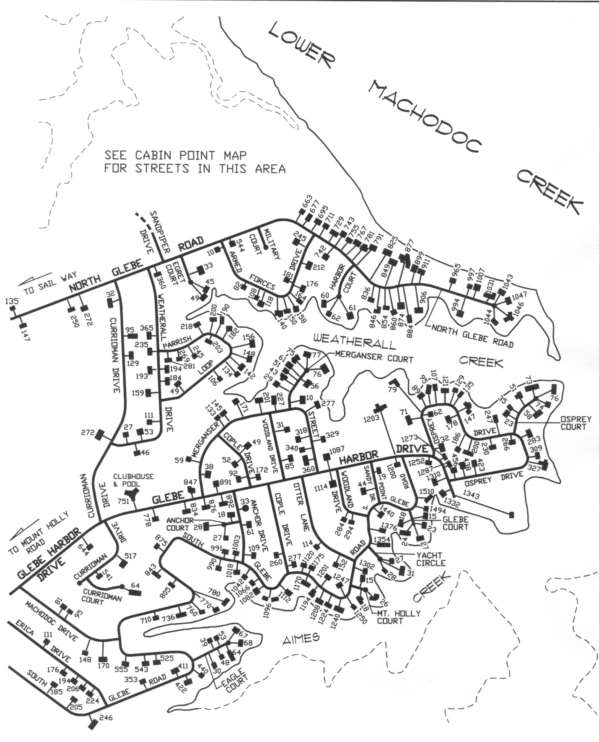

**Boat Storage**

**Clubhouse Complex**

* **Pool**
* **Picnic Pavilion**
* **Playground**
* **Basketball**
* **Tennis**

**Boat Ramp**

**Boat Storage & Beach Parking**

**Glebe Harbor Beach**