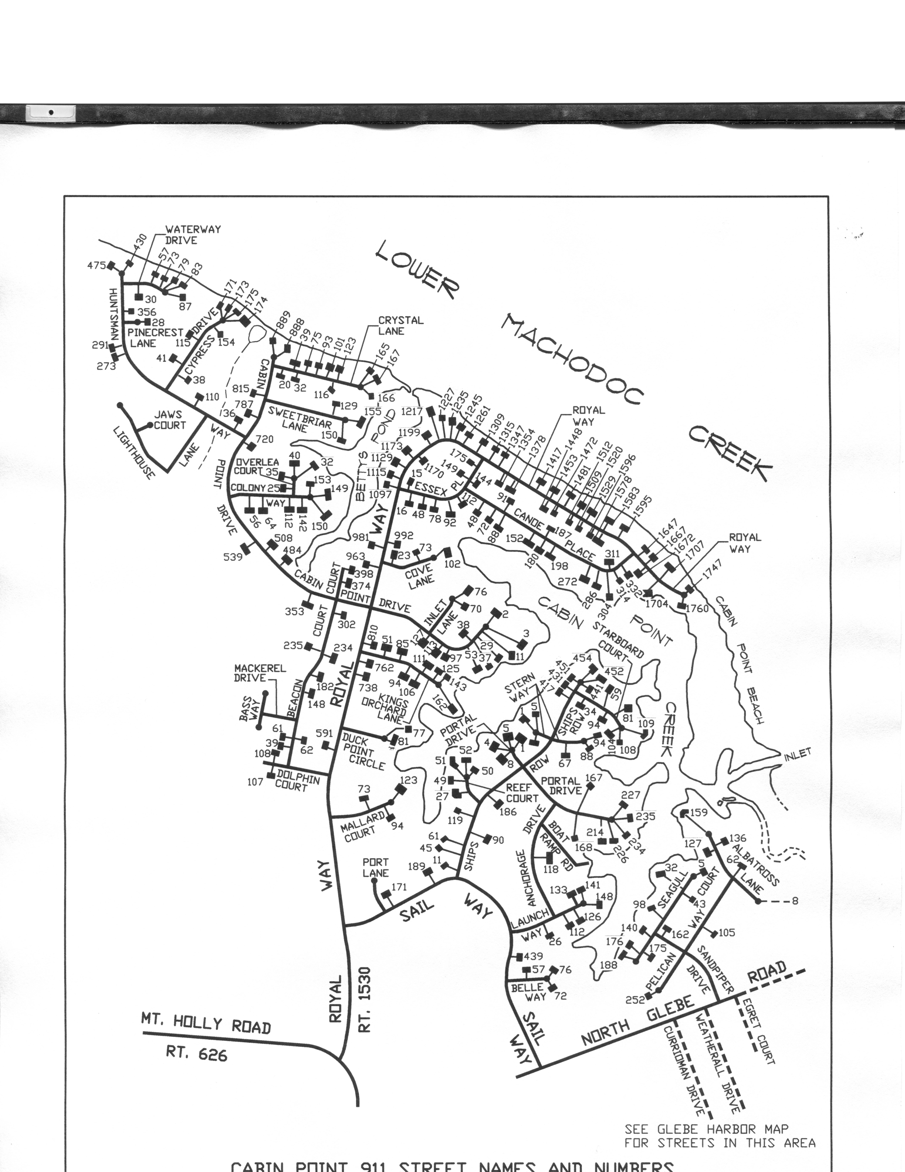

**Nature Trail to Beaver Pond Beach**

**Crystal Lane Beach**

**Boat Ramp**

**Beaver Pond Beach**

**Cabin Point Beach**